Task 13: Secure API Testing & Authorization Validation
1.Understand how REST APIs work and how applications use HTTP methods.
REST APIs allow applications to communicate with backend servers using the HTTP protocol. Clients send requests to API endpoints, and servers respond with data and status codes, usually in JSON format.
- GET – Retrieves data from the server
- POST – Creates new data
- PUT – Updates existing data
- DELETE – Removes data
Each method performs a specific action on a resource, and proper authentication and authorization are required to ensure secure communication.

2.Configure an API in Postman by setting the endpoint URL, headers, and request body based on the API documentation
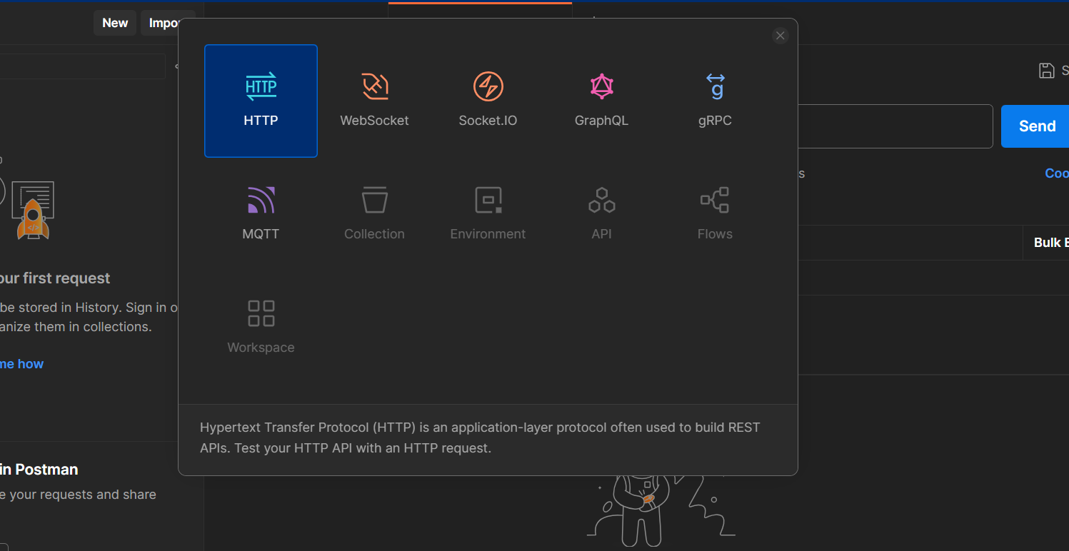
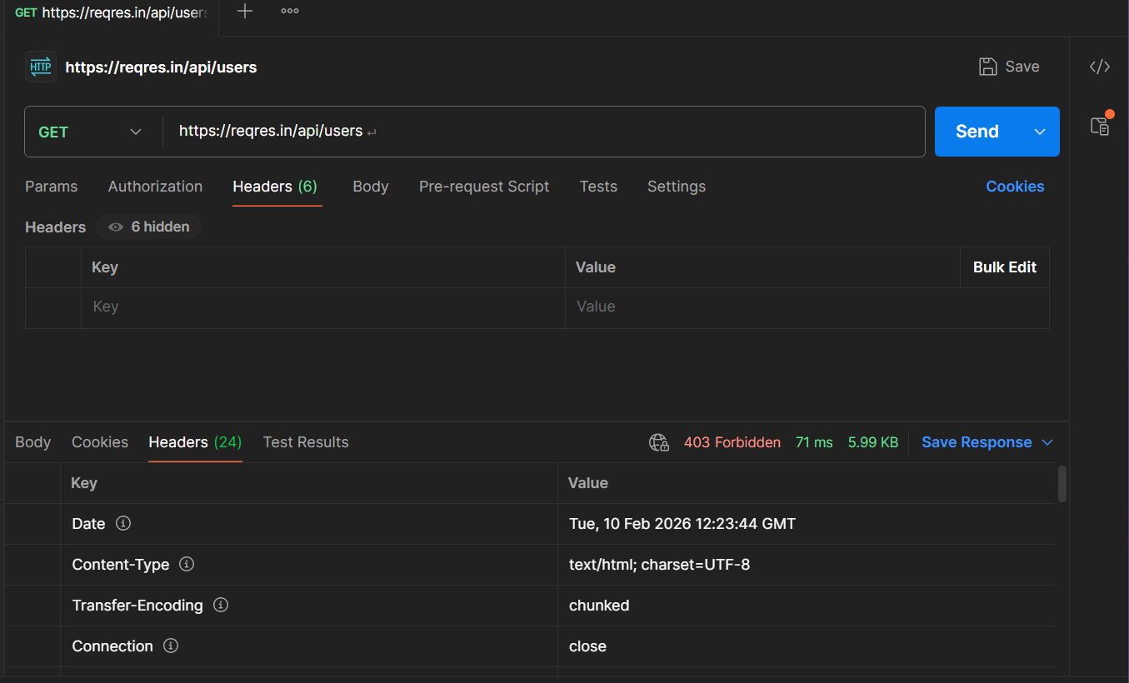

3.Test API authentication by sending requests with valid and invalid credentials to observe access behavior
Test with VALID Credentials
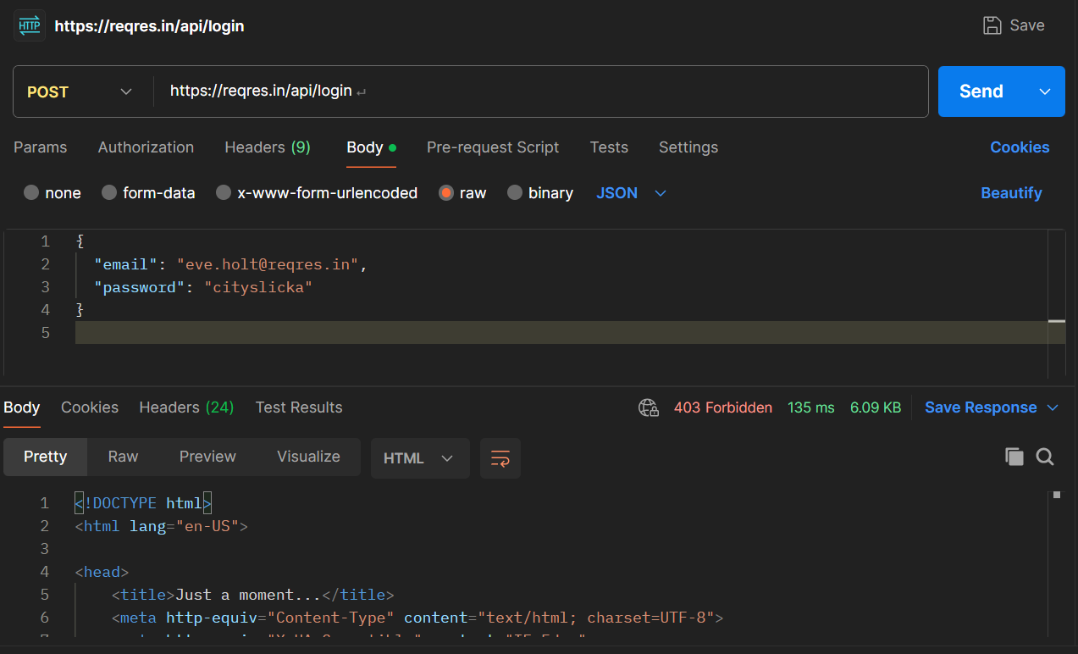
Test with INVALID Credentials
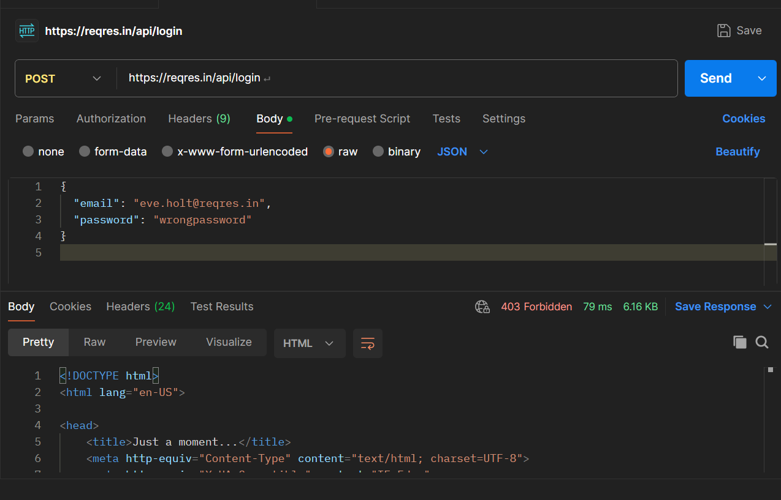

4.Remove authentication headers and resend requests to check if the API improperly allows unauthenticated access
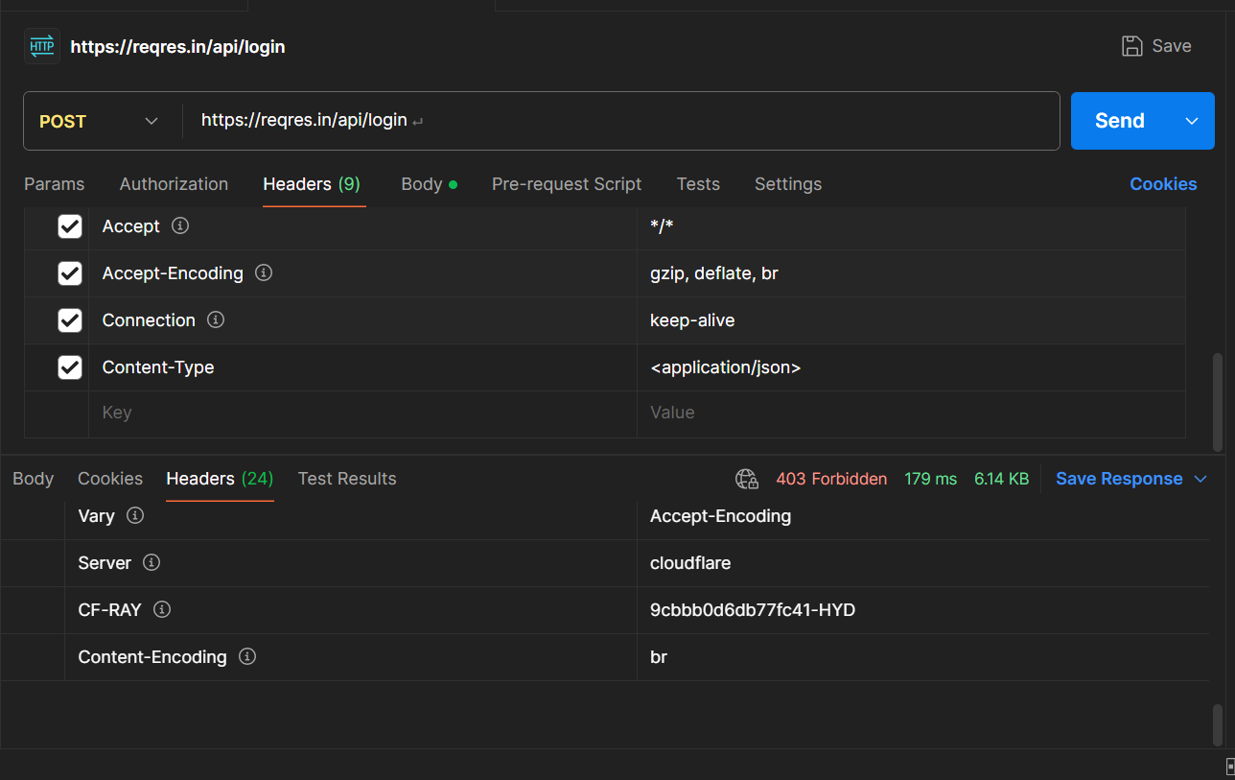
5.Modify resource identifiers in the request to test for broken authorization issues
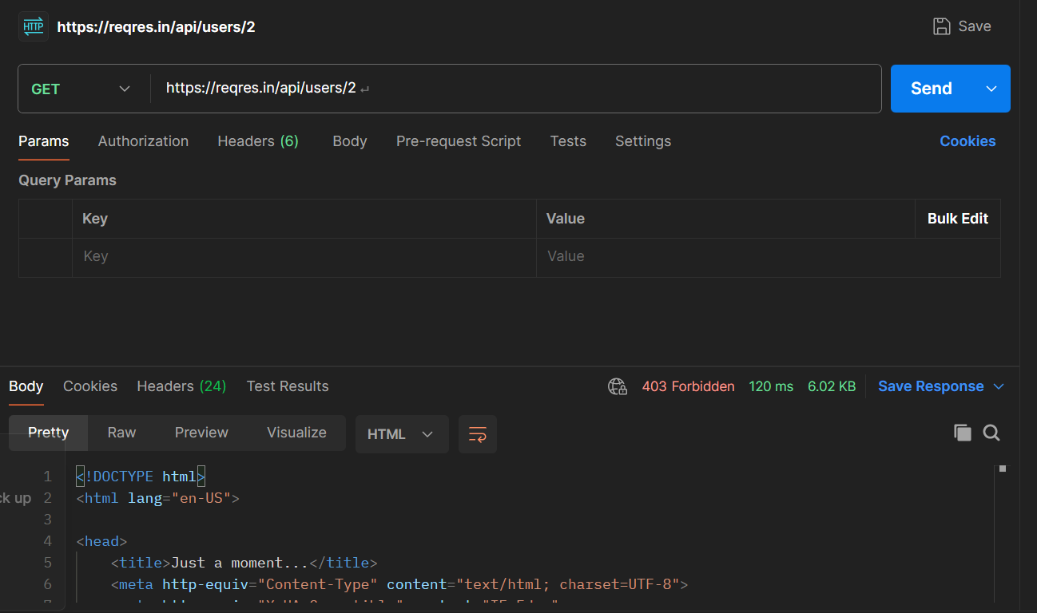
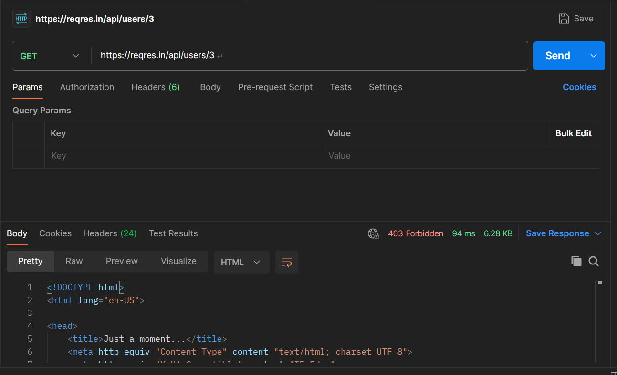

6.Send malformed or unexpected input values to observe input validation handling
Test 1: SQL-like Input
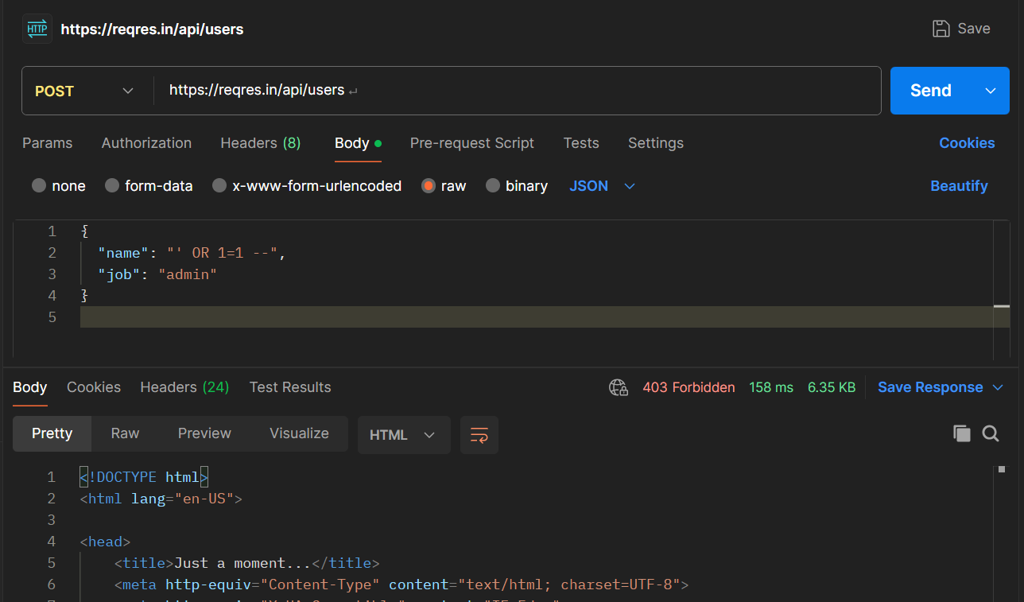
Test 2: Script Injection Input
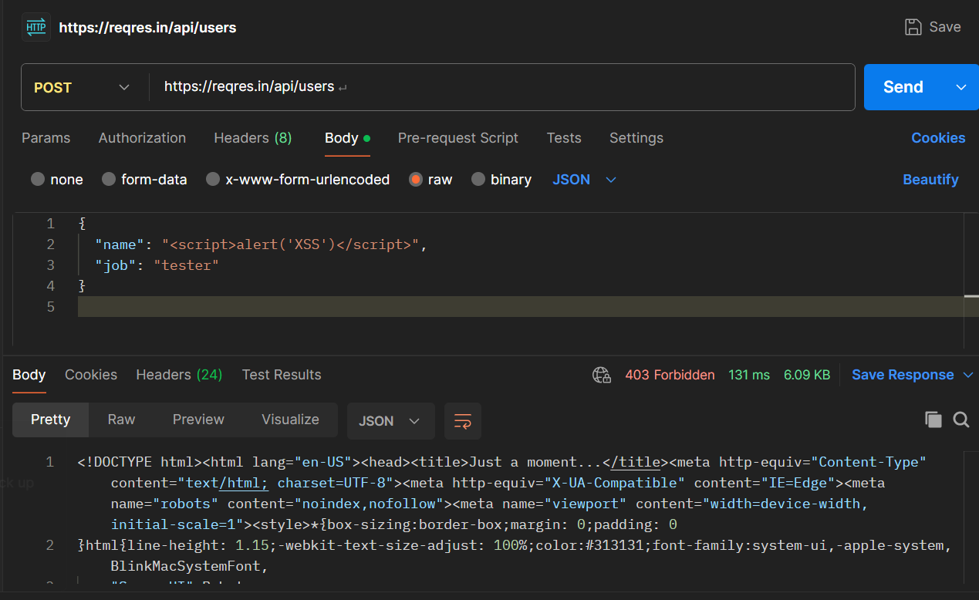
Test 3: Missing Required Field
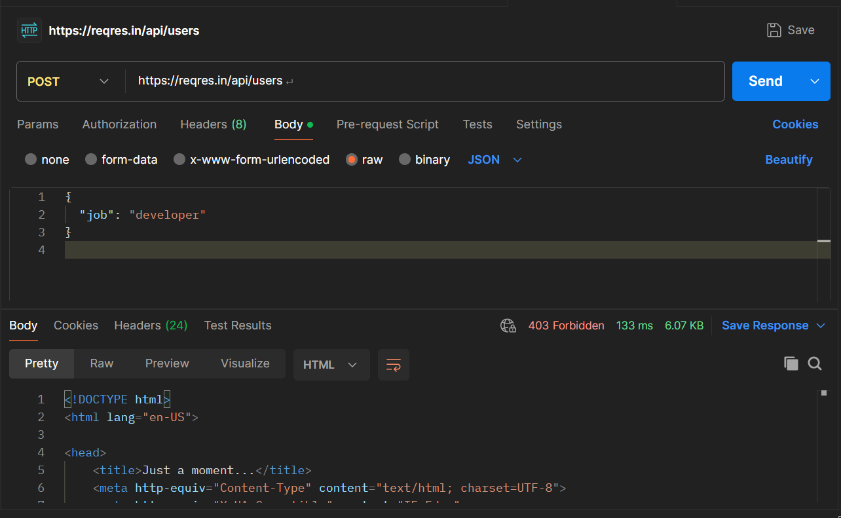
Test 4: Invalid Data Type
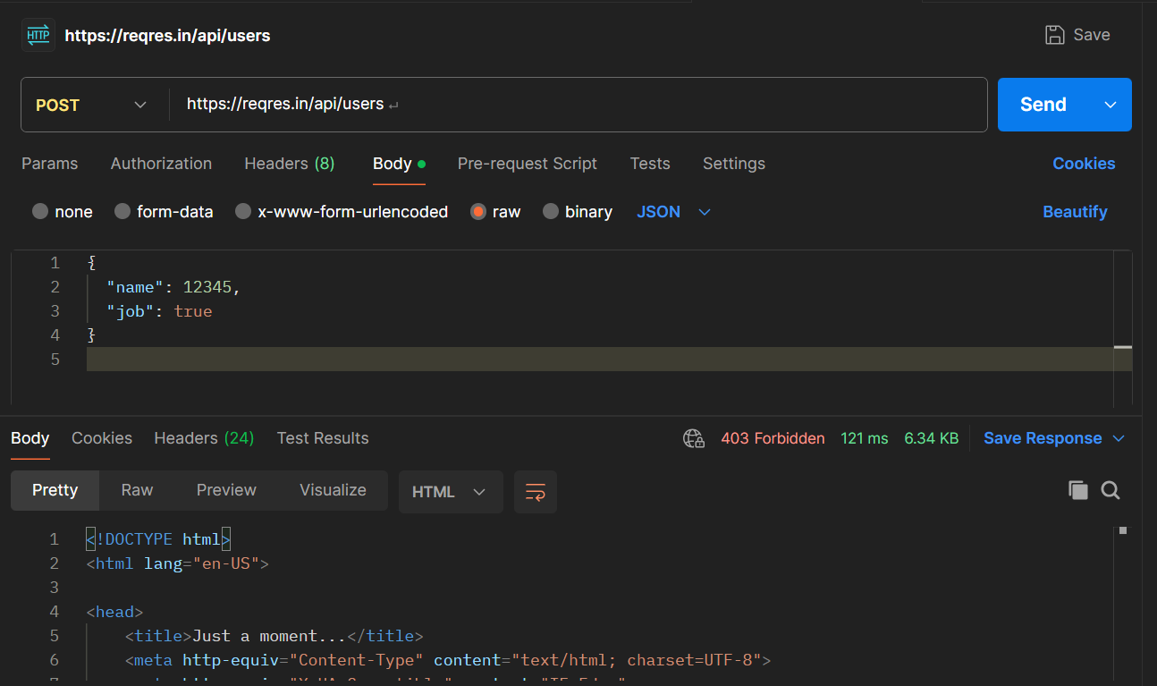
7.Perform multiple rapid requests to check whether rate limiting is enforced
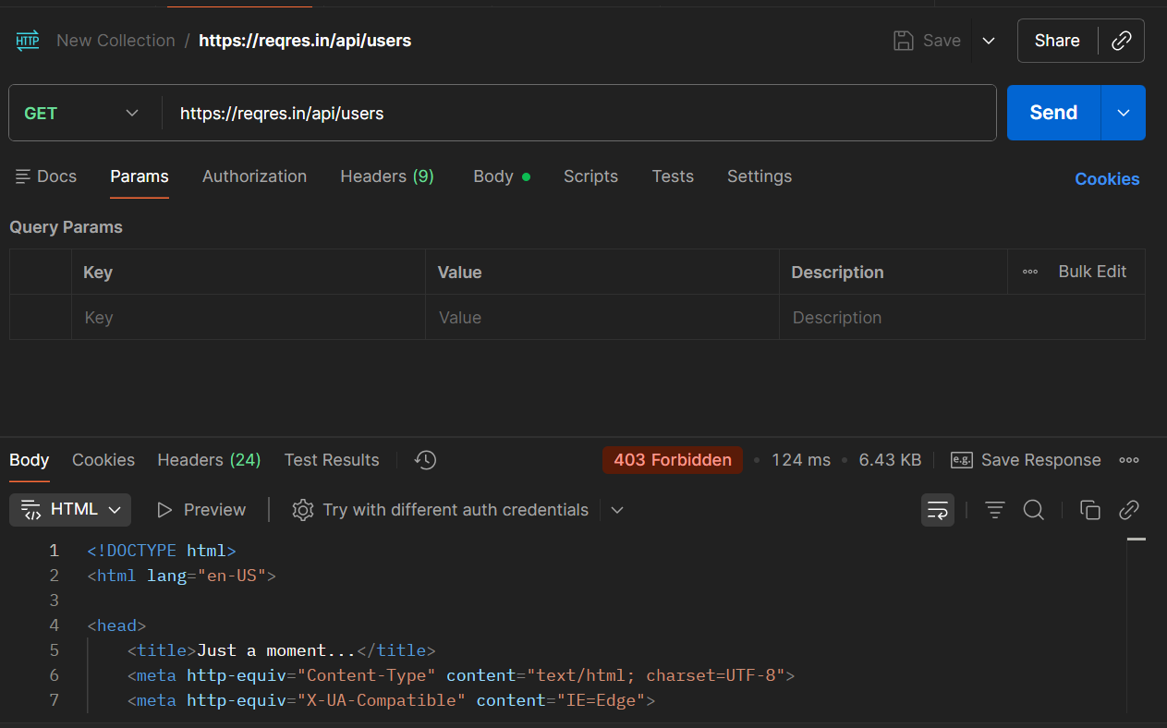

8.Review HTTP response codes and error messages for security weaknesses
- Observed HTTP response codes during API testing
- Common codes seen: 403 Forbidden, 400 Bad Request
- 403 Forbidden indicates access control is enforced
- Error messages were generic and did not expose system details
- No database errors or stack traces were revealed
- Proper error handling reduces information disclosure risks

Conclusion
- REST APIs were tested using Postman for common security issues
- Authentication and authorization controls were verified
- Unauthenticated access was properly restricted
- Input validation and rate limiting mechanisms were observed
- HTTP response codes and error handling were securely implemented
- No critical security misconfigurations were identified

